GET

FILE='C:\Users\GEORGE\Desktop\Stat Consulting\demo.sav'.

DATASET NAME DataSet1 WINDOW=FRONT.

FREQUENCIES VARIABLES=ownpda owntv

/ORDER=ANALYSIS.

**Frequencies**

|  |  |  |
| --- | --- | --- |
| **Notes** | | |
| Output Created | | 24-OCT-2022 18:11:59 |
| Comments | |  |
| Input | Data | C:\Users\GEORGE\Desktop\Stat Consulting\demo.sav |
| Active Dataset | DataSet1 |
| Filter | <none> |
| Weight | <none> |
| Split File | <none> |
| N of Rows in Working Data File | 6400 |
| Missing Value Handling | Definition of Missing | User-defined missing values are treated as missing. |
| Cases Used | Statistics are based on all cases with valid data. |
| Syntax | | FREQUENCIES VARIABLES=ownpda owntv  /ORDER=ANALYSIS. |
| Resources | Processor Time | 00:00:00.02 |
| Elapsed Time | 00:00:00.05 |

[DataSet1] C:\Users\GEORGE\Desktop\Stat Consulting\demo.sav

|  |  |  |  |
| --- | --- | --- | --- |
| **Statistics** | | | |
|  | | Owns PDA | Owns TV |
| N | Valid | 6400 | 6400 |
| Missing | 0 | 0 |

**Frequency Table**

|  |  |  |  |  |  |
| --- | --- | --- | --- | --- | --- |
| **Owns PDA** | | | | | |
|  | | Frequency | Percent | Valid Percent | Cumulative Percent |
| Valid | No | 5093 | 79.6 | 79.6 | 79.6 |
| Yes | 1307 | 20.4 | 20.4 | 100.0 |
| Total | 6400 | 100.0 | 100.0 |  |

|  |  |  |  |  |  |
| --- | --- | --- | --- | --- | --- |
| **Owns TV** | | | | | |
|  | | Frequency | Percent | Valid Percent | Cumulative Percent |
| Valid | No | 63 | 1.0 | 1.0 | 1.0 |
| Yes | 6337 | 99.0 | 99.0 | 100.0 |
| Total | 6400 | 100.0 | 100.0 |  |

FREQUENCIES VARIABLES=ownpda owntv

/BARCHART FREQ

/ORDER=ANALYSIS.

**Frequencies**

|  |  |  |
| --- | --- | --- |
| **Notes** | | |
| Output Created | | 24-OCT-2022 18:58:32 |
| Comments | |  |
| Input | Data | C:\Users\GEORGE\Desktop\Stat Consulting\demo.sav |
| Active Dataset | DataSet1 |
| Filter | <none> |
| Weight | <none> |
| Split File | <none> |
| N of Rows in Working Data File | 6400 |
| Missing Value Handling | Definition of Missing | User-defined missing values are treated as missing. |
| Cases Used | Statistics are based on all cases with valid data. |
| Syntax | | FREQUENCIES VARIABLES=ownpda owntv  /BARCHART FREQ  /ORDER=ANALYSIS. |
| Resources | Processor Time | 00:00:02.14 |
| Elapsed Time | 00:00:08.70 |

[DataSet1] C:\Users\GEORGE\Desktop\Stat Consulting\demo.sav

|  |  |  |  |
| --- | --- | --- | --- |
| **Statistics** | | | |
|  | | Owns PDA | Owns TV |
| N | Valid | 6400 | 6400 |
| Missing | 0 | 0 |

**Frequency Table**

|  |  |  |  |  |  |
| --- | --- | --- | --- | --- | --- |
| **Owns PDA** | | | | | |
|  | | Frequency | Percent | Valid Percent | Cumulative Percent |
| Valid | No | 5093 | 79.6 | 79.6 | 79.6 |
| Yes | 1307 | 20.4 | 20.4 | 100.0 |
| Total | 6400 | 100.0 | 100.0 |  |

|  |  |  |  |  |  |
| --- | --- | --- | --- | --- | --- |
| **Owns TV** | | | | | |
|  | | Frequency | Percent | Valid Percent | Cumulative Percent |
| Valid | No | 63 | 1.0 | 1.0 | 1.0 |
| Yes | 6337 | 99.0 | 99.0 | 100.0 |
| Total | 6400 | 100.0 | 100.0 |  |

**Bar Chart**

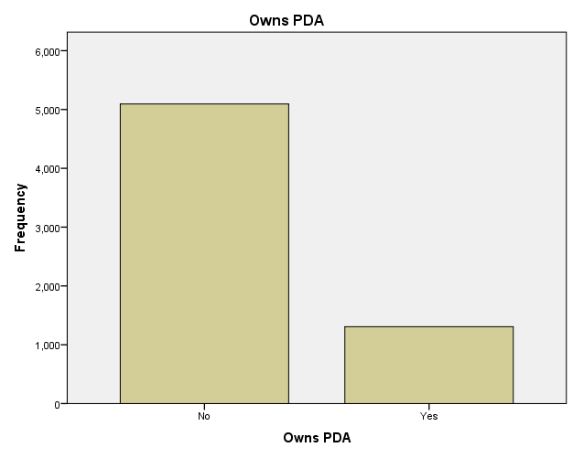

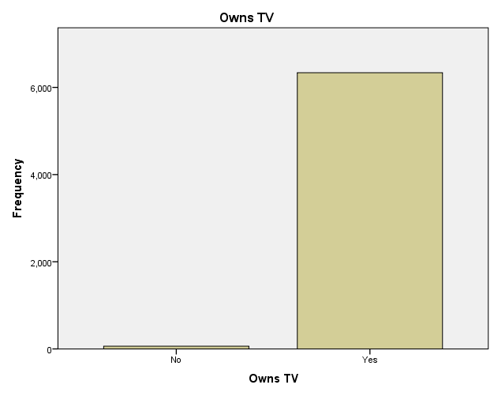

**SUMMARY**

In addition to the frequency tables, the same information is now displayed in the form of bar charts, making it easy to see that most people do not own PDAs but almost everyone owns a TV.